NSLookup: Standard Tool Guide

Ruth Faith Wnadabwa
Deakin University
August 4 2025

NSLookup
NSLookup is one of the most useful network troubleshooting tool that is capable of querying Domain Name System (DNS) servers and sourcing the essential information of domain names, IP address, and DNS records. It is common in the software tool-box of network administrators, penetration testers and also system engineers to diagnose DNS resolving problems, check domain settings and also mapping network structure. This guide introduces NSLookup as part of the Deakin Detonator Toolkit, outlining its usage in DNS inspection and analysis.
Warning: This feature is for educational use only. It generates fictional scenarios based on real vulnerabilities. Do not use any exploit steps in real-world environments unless you have proper authorization.

Setup and Launch
The Deakin Detonator Toolkit integrates NSLookup as a DNS diagnostic and reconnaissance tool. In order to run the tool locally when developing or customizing, the developer should use:
yarn run tauri dev
or (for node users)
npm run tauri dev
This command builds and runs the GUI version of the tool in a local safe run time environment provided by Tauri. It also enables interface testing in real time and provides an interface with system-level APIs.

Step-by-Step UI Walkthrough
- Enter a Target Address
In the box labeled “Please enter the IP Address for NSLookup” enter either a valid domain name (for example, google.com) or an IP address (for example, 127.0.0.1).
- Specify the type of DNS record to query
From the selection box labelled “Query Type” in the GUI, select the DNS record type from the options provided. The options available include:
- A (Address)
- MX (Mail Exchange)
- NS (Name Server)
- CNAME (Canonical Name)
- TXT (Text)
- Optional: Output File
To save automatically the results fill a desired filename (for example output.txt) in the “Output filename” field.
- Start the Scan
The lookup is performed by clicking the Scan button. The Output section below will have the results.
- Save Results (Possible)
When an output filename was given, you can click Save Output to File to save the result.
- Clear Results
To start over a new query, just click Clear Output button.

Configuration

Flags & Functions
Option | Description | Example
-type=TYPE | Specifies the type of DNS record to query (A, MX, CNAME, NS, CNAME, TXT) | -type=A
- DNS Record Type (-type)
Determines what kind of DNS data is returned. Use A for IPv4 address, MX for mail servers, NS for name servers, CNAME for canonical names, TXT for text.

Input output clarity

User inputs
Field | Description | Example
IP/Domain Input Field | Required. Enter domain name or IP address. | google.com, 8.8.8.8
Output Filename | Optional. Set if you want to save output. | results.txt

Expected Output Fields
Field | Description
Server | DNS server that was used to resolve the query
Address | IP of the DNS server (with port, if applicable)
Name | Resolved domain name from query
Address | Resolved IP address(es) associated with the domain
Process completed | Confirms whether the lookup succeeded or encountered an error

Tool Usage

UI Walkthrough
- Configuration
To set up a lookup, one should enter the target address in the field labelled “Please enter the IP Address of nslookup” as shown in Figure 1. It may be a domain, such as google.com, or an IP address, such as 127.0.0.1. The results may also be automatically saved by specifying (optionally) a filename in the field, "Output filename."
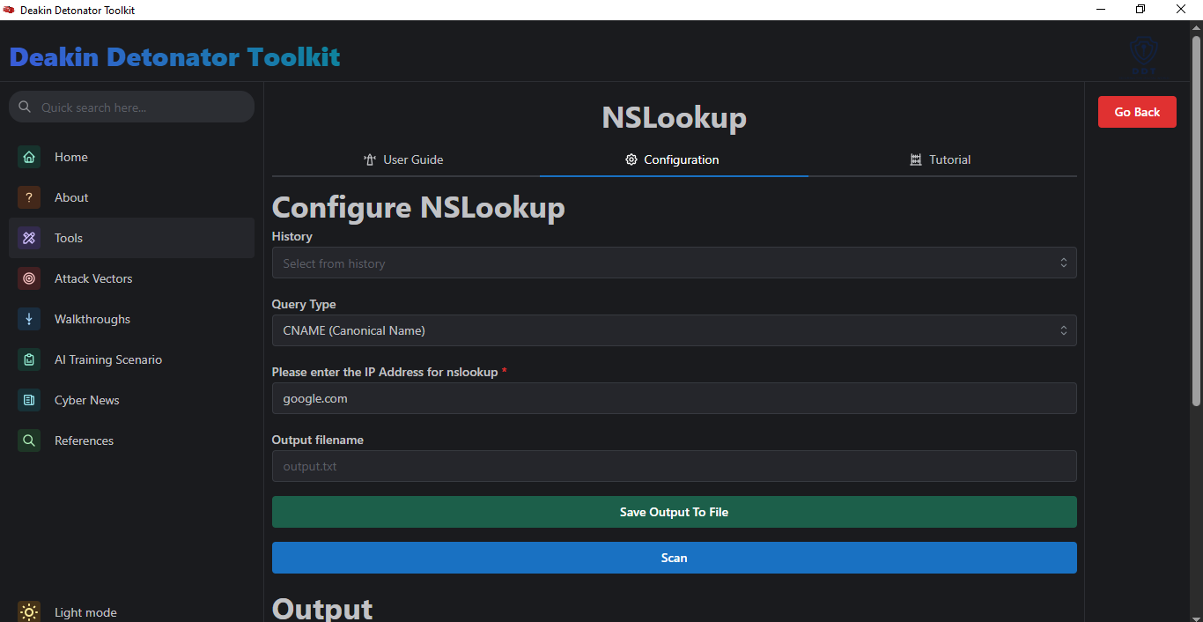
Figure 1:The screenshot of the NSLookup configuration user interface showing the fields for the address to scan, the query type, and the output filename..
- Scan and Output
After insertion of the details, press the “Scan” button to generate the search. The lookup results will be presented in “Output” section beneath the scan button. The result will contain the DNS server against which the query was made, its IP address, the resolved domain name and the resulting IP address(es). Successful lookup is confirmed with a message stating that the process has been completed successfully.
- Saving the Results and Clearing
The results can also be saved to a file that you named via the “Save Output to File” button. To run a new query, click the “Clear Output” button to clear the result and begin again.

Example
In the image shown in Figure 2, an NSLookup for "google.com" returns a non-authoritative answer with the resolved IP address 172.217.170.206.
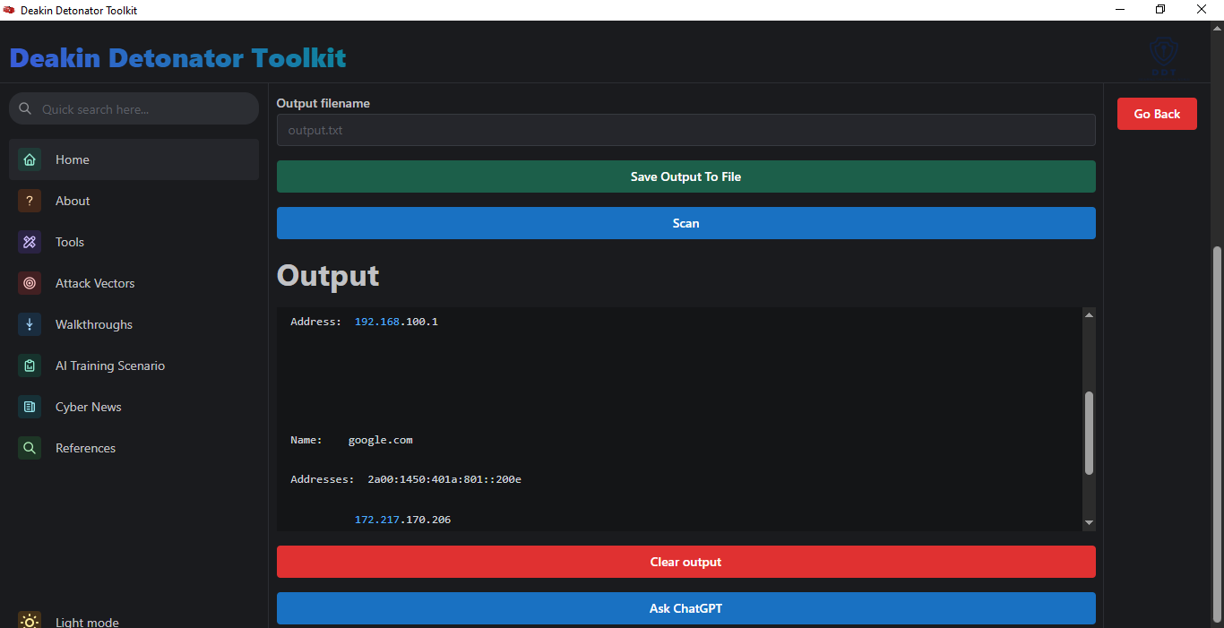
Figure 2: This screenshot shows the output from the NSLookup tool for google.com.

Output and Interpretation
After running the NSLookup tool in the Deakin Detonator Toolkit, the “Output” section displays a breakdown of the DNS query and its resolution. The output fields are:
- Server: The DNS server used to resolve the query.
- Address: The IP address of the DNS server.
- Name: The domain name that was resolved from the query.
- Address: The resolved IP address(es) associated with the domain.
- Process completed: A confirmation message indicating whether the lookup was successful or encountered an error.

Save, Clear and Reset
To save the results of your lookup, first, enter a desired filename, such as "output.txt," in the “Output filename” field before you run the scan. Once the lookup is complete, click the “Save Output to File” button to save the results to the specified file. To prepare for a new query, simply click the “Clear Output” button. This action clears the previous results, allowing you to start a new lookup.

